Do You Know Go?
Go is a board game that originated in China more over 2000 years ago. The game is rich in strategy and heritage; it is played by millions of people all around the world. If you know the game, or have ever wanted to learn, come check out the Go and Chess Club.

Chinese  圍棋  Pronounced “wéiqí” | Korean  바둑  Pronounced “baduk”
Japanese  囲碁  Pronounced “igo” | English  Go

Grand Valley’s Go and Chess Club
A club for playing (and learning how to play) strategy board games.
Test your skills, learn how to play, and hang out with fellow strategy game fans.

Wednesdays at 6pm and Fridays at 5pm in Kirkhof’s South Lounge
(across from the Lobby Shop, near the LGBT Center)
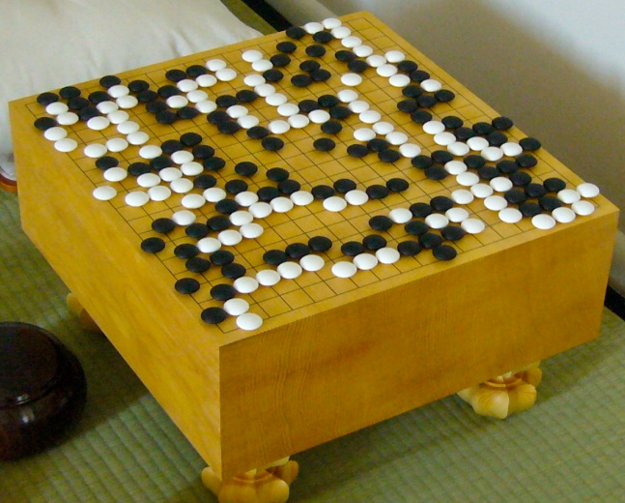

" A few moments to learn, a lifetime to master.”
– Ancient Go Proverb

